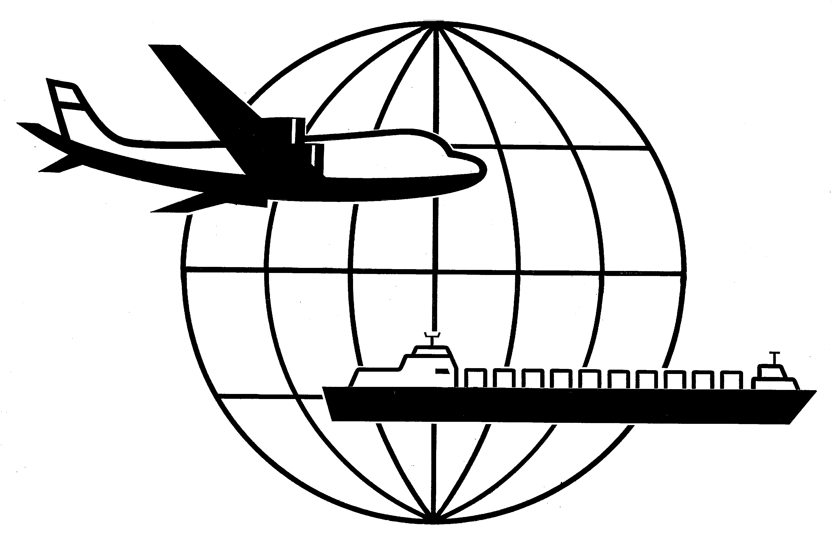
Universal Forwarding Overseas, Ltd.

Newsletter
February 20, 2015Universal Forwarding Overseas, Ltd.
WEST COAST LABOR NEGOTIATIONS UPDATE

The port congestion situation and continuing slow down of labor workers on the West Coast have caused several steamship lines to suspend the release of empty equipment or have stopped accepting new bookings via West Coast ports until further notice. Should your shipment be effected by this latest happening, your UFO CSR will be providing an alternative booking option.

This morning conflicting reports have emerged on whether West Coast employers and dockworkers had finally reached an agreement after more than 9 months of negotiations. The rumors reflect the mounting pressure of the International Longshore and Warehouse Union (ILWU) and the Pacific Maritime Association (PMA) and the deadline imposed by the U.S. Labor Secretary to present themselves to Washington DC if no deal was worked out today.

UFO will continue to keep our clients updated and will advise once an agreement has been reached.

If you have any questions regarding the above information, please contact Marc Mugfor at mmugfor@ufoltd.com.

WISCONSIN
UNIVERSAL FORWARDING OVERSEAS, LTD.
941 North Perkins Street
Appleton, WI 54914
Phone: 920-731-0822
Fax: 920-731-0293

ILLINOIS
UNIVERSAL FORWARDING OVERSEAS, LTD.
1099 West Hawthorn Drive
Itasca, IL 60143
Phone: 630-766-7121
Fax: 630-766-7161

