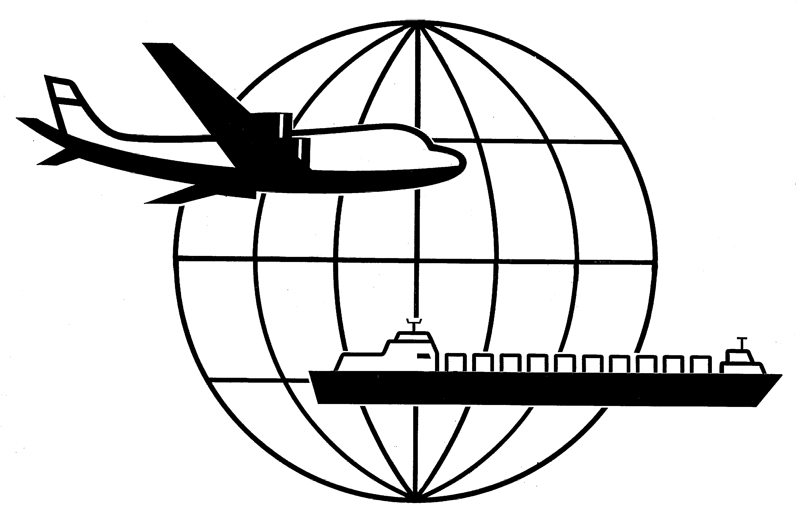
Universal Forwarding Overseas, Ltd.

Newsletter
February 23, 2015 Established 1978

PMA, ILWU Announce West Coast Waterfront Contract

SAN FRANCISCO (Feb. 20, 2015) – The Pacific Maritime Association and the International Longshore and Warehouse Union today announced a tentative agreement on a new five-year contract covering workers at all 29 West Coast ports. The deal was reached with assistance from U.S. Secretary of Labor Tom Perez and Federal Mediation and Conciliation Service Deputy Director Scot Beckenbaugh. The parties will not be releasing details of the agreement at this time. The agreement is subject to ratification by both parties.

“After more than nine months of negotiations, we are pleased to have reached an agreement that is good for workers and for the industry,” said PMA President James McKenna and ILWU President Bob McEllrath in a joint statement. “We are also pleased that our ports can now resume full operations.”

If you have any questions regarding the above information, please contact Marc Mugfor at mmugfor@ufoltd.com.

WISCONSIN
UNIVERSAL FORWARDING OVERSEAS, LTD.
941 North Perkins Street
Appleton, WI 54914
Phone: 920-731-0822
Fax: 920-731-0293

ILLINOIS
UNIVERSAL FORWARDING OVERSEAS, LTD.
1099 Hawthorn Dr.
Itasca, IL 60143
Phone: 630-766-7121
Fax: 630-766-7161

