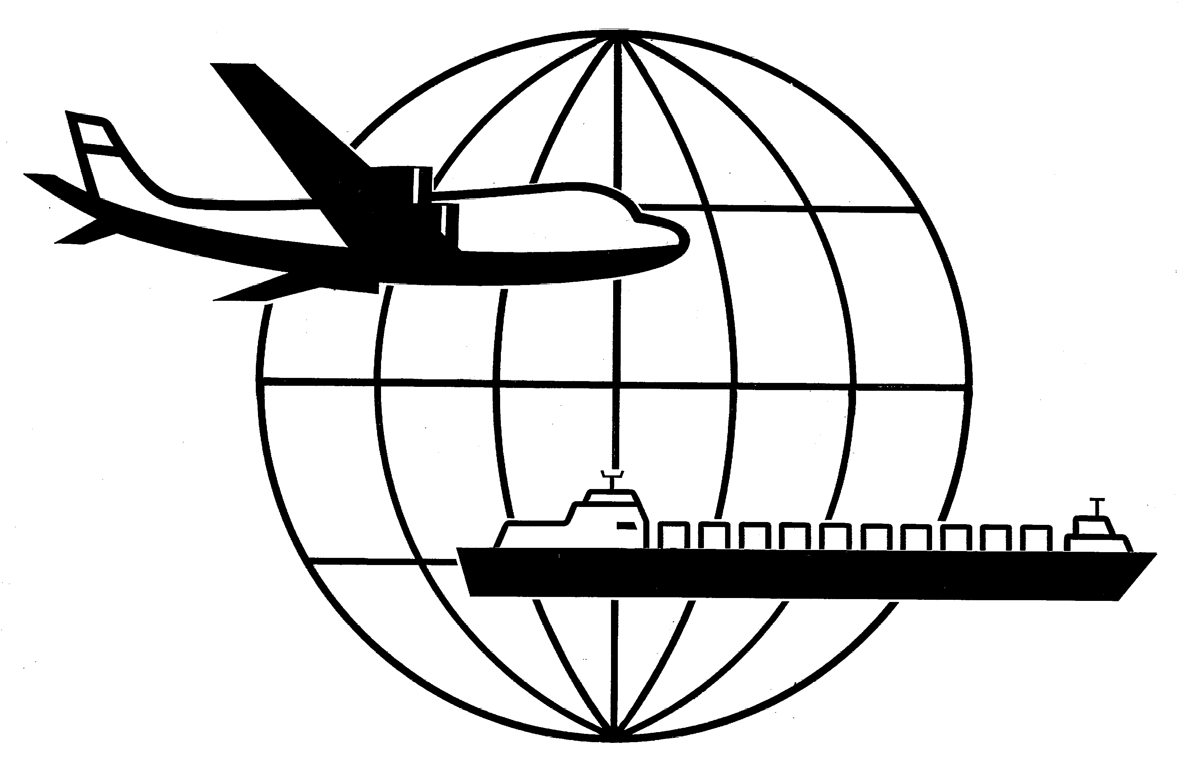
Universal Forwarding Overseas, Ltd.

Newsletter
March, 2005Universal Forwarding Overseas, Ltd.
Solid Wood Packing - ISPM 15
The International Plant Protection Convention’s (IPPC) ISPM 15 guidelines governing the treatment of solid wood packing material are currently being implemented by 118 countries. Subject to change on a per country basis, the current timeframes for implementation for various countries are as follows:
- European Union (EU) Scheduled implementation March 1, 2005. For a current listing of EU members, see www.eurunion.org.
- Turkey – Scheduled implementation January 1, 2006
- Chile, Korea, Philippines – Scheduled implementation June 1, 2005
- Colombia, Costa Rica – Scheduled implementation September 15, 2005

United States/Australia Free Trade Agreement
The Free Trade Agreement between the United States and Australia became effective January 1, 2005. The Agreement provides for duty-free trade between the two countries on most manufactured and agricultural products.
www.ita.doc.gov is a very useful website to confirm duty rates.

Mandatory Electronic Filing of the Shipper’s Export Declaration
The Security Assistance Act of 2002 provided the Secretary of Commerce the authority to issue regulations requiring full electronic filing of all export information. The anticipated effective date is fall of 2005. Currently, 94% of eligible export shipments are filed electronically via AES (Automated Export System). For information on electronic filing, please refer to www.aesdirect.com.

Australia/New Zealand Container Fumigation
Member carriers of the U.S. Australasia Discussion Agreement (USADA) announced effective April 15, 2005 they will no longer coordinate container fumigation services. Fumigation companies will continue to provide services, though the cost and time required will increase due to the additional drayage and coordination. As an alternative to fumigation, clients may consider the use of packing material and dunnage that is ISPM 15 compliant.

Consignee Contact Information
UFO encourages clients to include importer contact information on export paperwork. A name, telephone, facsimile and/or email address is beneficial in contacting your customer in a timely manner regarding shipment arrival.

Carrier Surcharges
Due to the recent fluctuation in fuel costs, several air and ocean carriers are implementing increases to the fuel surcharge. In addition, ocean carriers are implementing a “carrier security charge” to meet the costs incurred to comply with the requirements of the International Ship and Port Facility Security (ISPS) code.

WISCONSIN
UNIVERSAL FORWARDING OVERSEAS, LTD.
941 North Perkins Street
Appleton, WI 54914
Phone: 920-731-0822
Fax: 920-731-0293

ILLINOIS
UNIVERSAL FORWARDING OVERSEAS, LTD.
1104 Tower Lane
Bensenville, IL 60106
Phone: 630-766-7121
Fax: 630-766-7161

