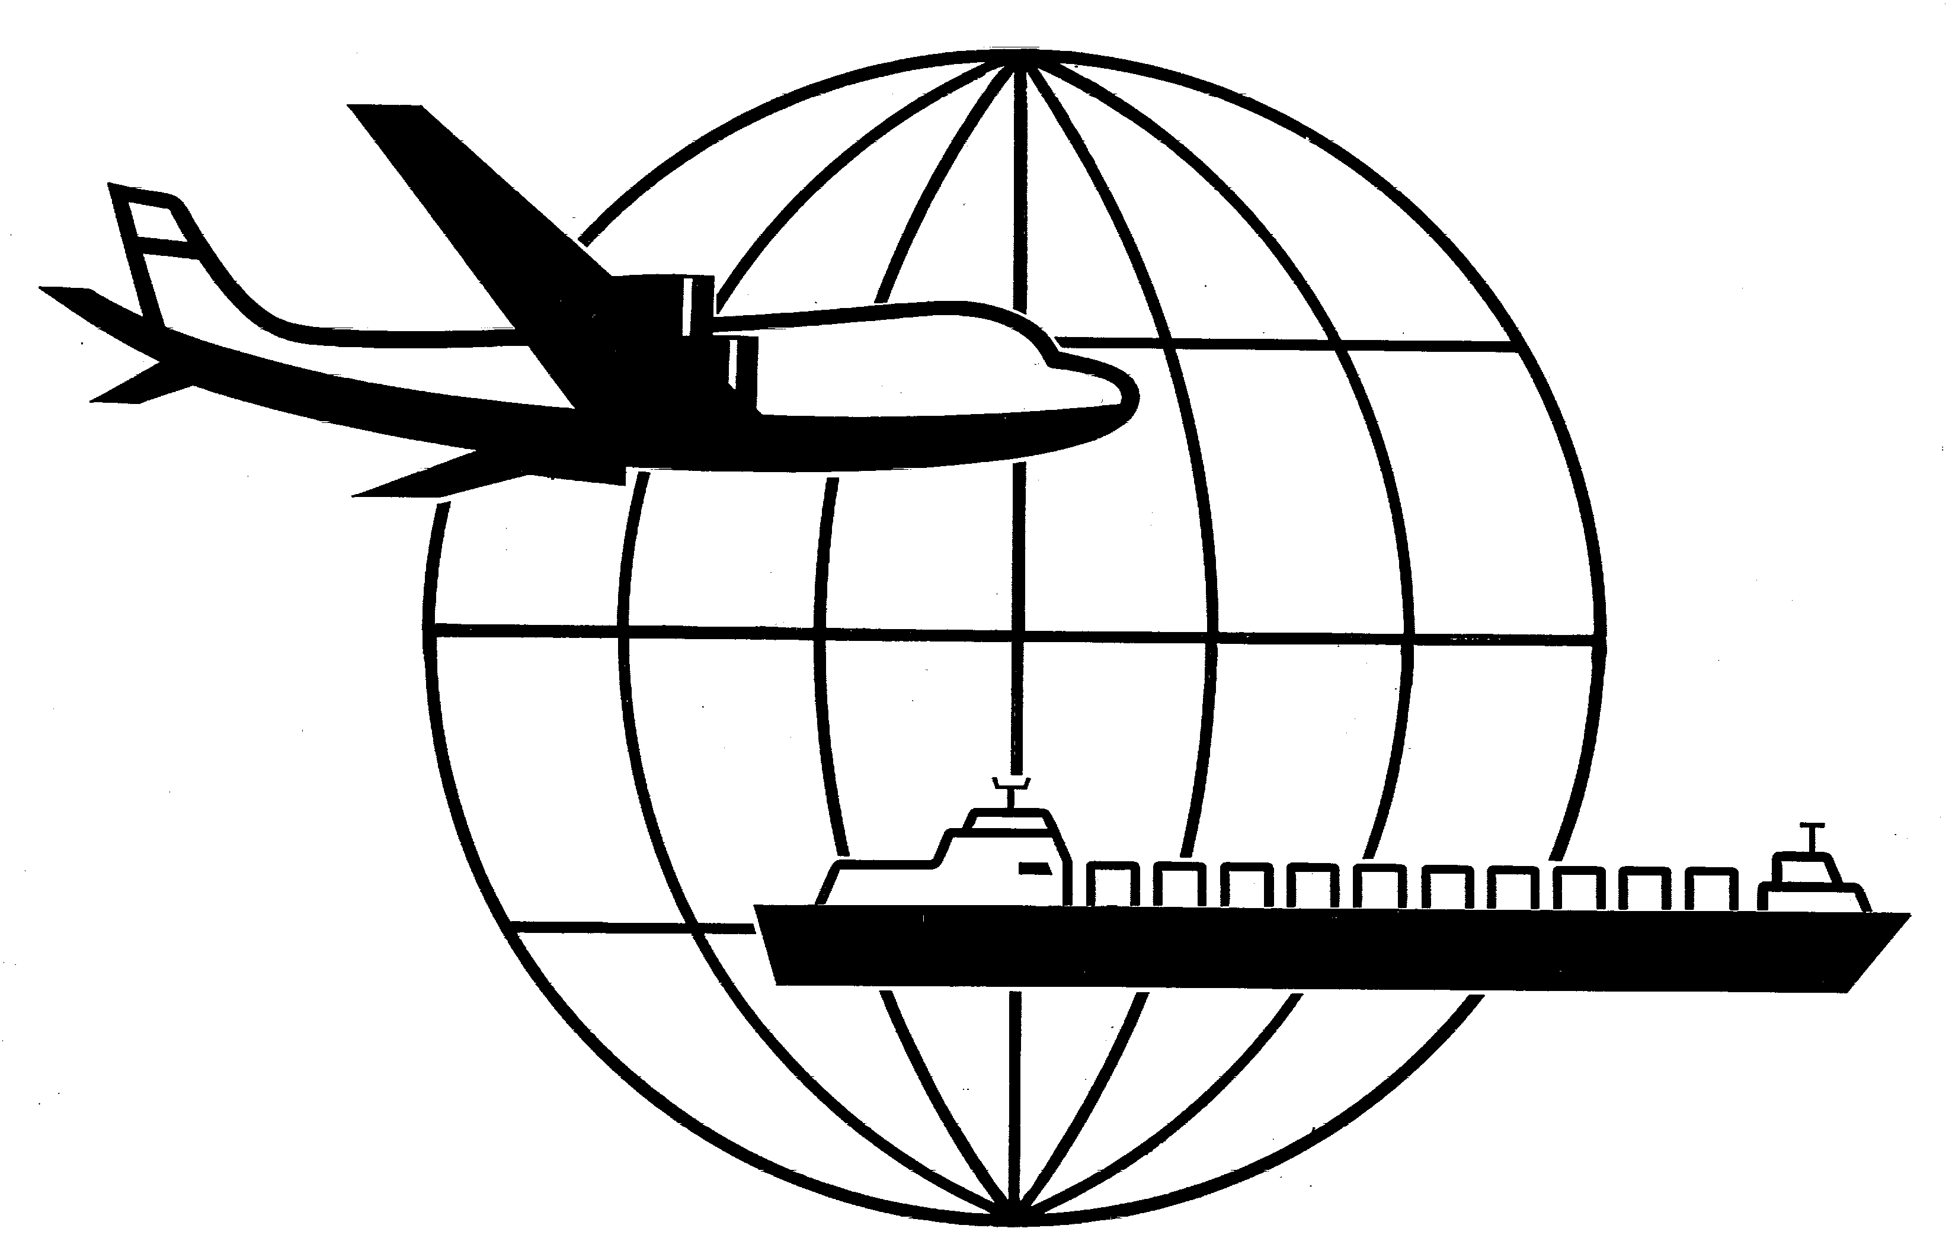
Universal Forwarding Overseas, Ltd.

Newsletter
July 2013Universal Forwarding Overseas, Ltd.
EGYPT - POLITICAL UNREST
UFO is monitoring the political unrest situation in Egypt daily. Carriers are reporting their offices and the ports are open but there are delays due to congestion at the ports. In situations like this, there is potential for demurrage or detention. We will continue to keep you advised.

OAKLAND, CA - TERMINAL STRIKE
The International Longshore and Warehouse Union (ILWU) has set up pickets today in front of Oakland International Container Terminal. As a result, terminal and gate operations have been stopped. An Arbitration hearing was held this morning and the Area Arbitrator has ruled that the ILWU pickets in Oakland are non bona fide and has ordered ILWU back to work.

RATED OCEAN BILL OF LADING REQUIREMENT
Several ocean carriers are now requiring that bills of lading must be rated for several destinations in Central and South America (see list below). Our results after polling 3 steamship lines reflect that each carrier varies with their requirements per country.

Argentina
Brazil
Chile
Costa Rica
Dominican Republic
Ecuador
Guatemala
Honduras
Nicaragua
Peru

If you have any questions regarding the above information, please contact Marc Mugfor at mmugfor@ufoltd.com

WISCONSIN
UNIVERSAL FORWARDING OVERSEAS, LTD.
941 North Perkins Street
Appleton, WI 54914
Phone: 920-731-0822
Fax: 920-731-0293

ILLINOIS
UNIVERSAL FORWARDING OVERSEAS, LTD.
1099 Hawthorn Dr.
Itasca, IL 60143
Phone: 630-766-7121
Fax: 630-766-7161

