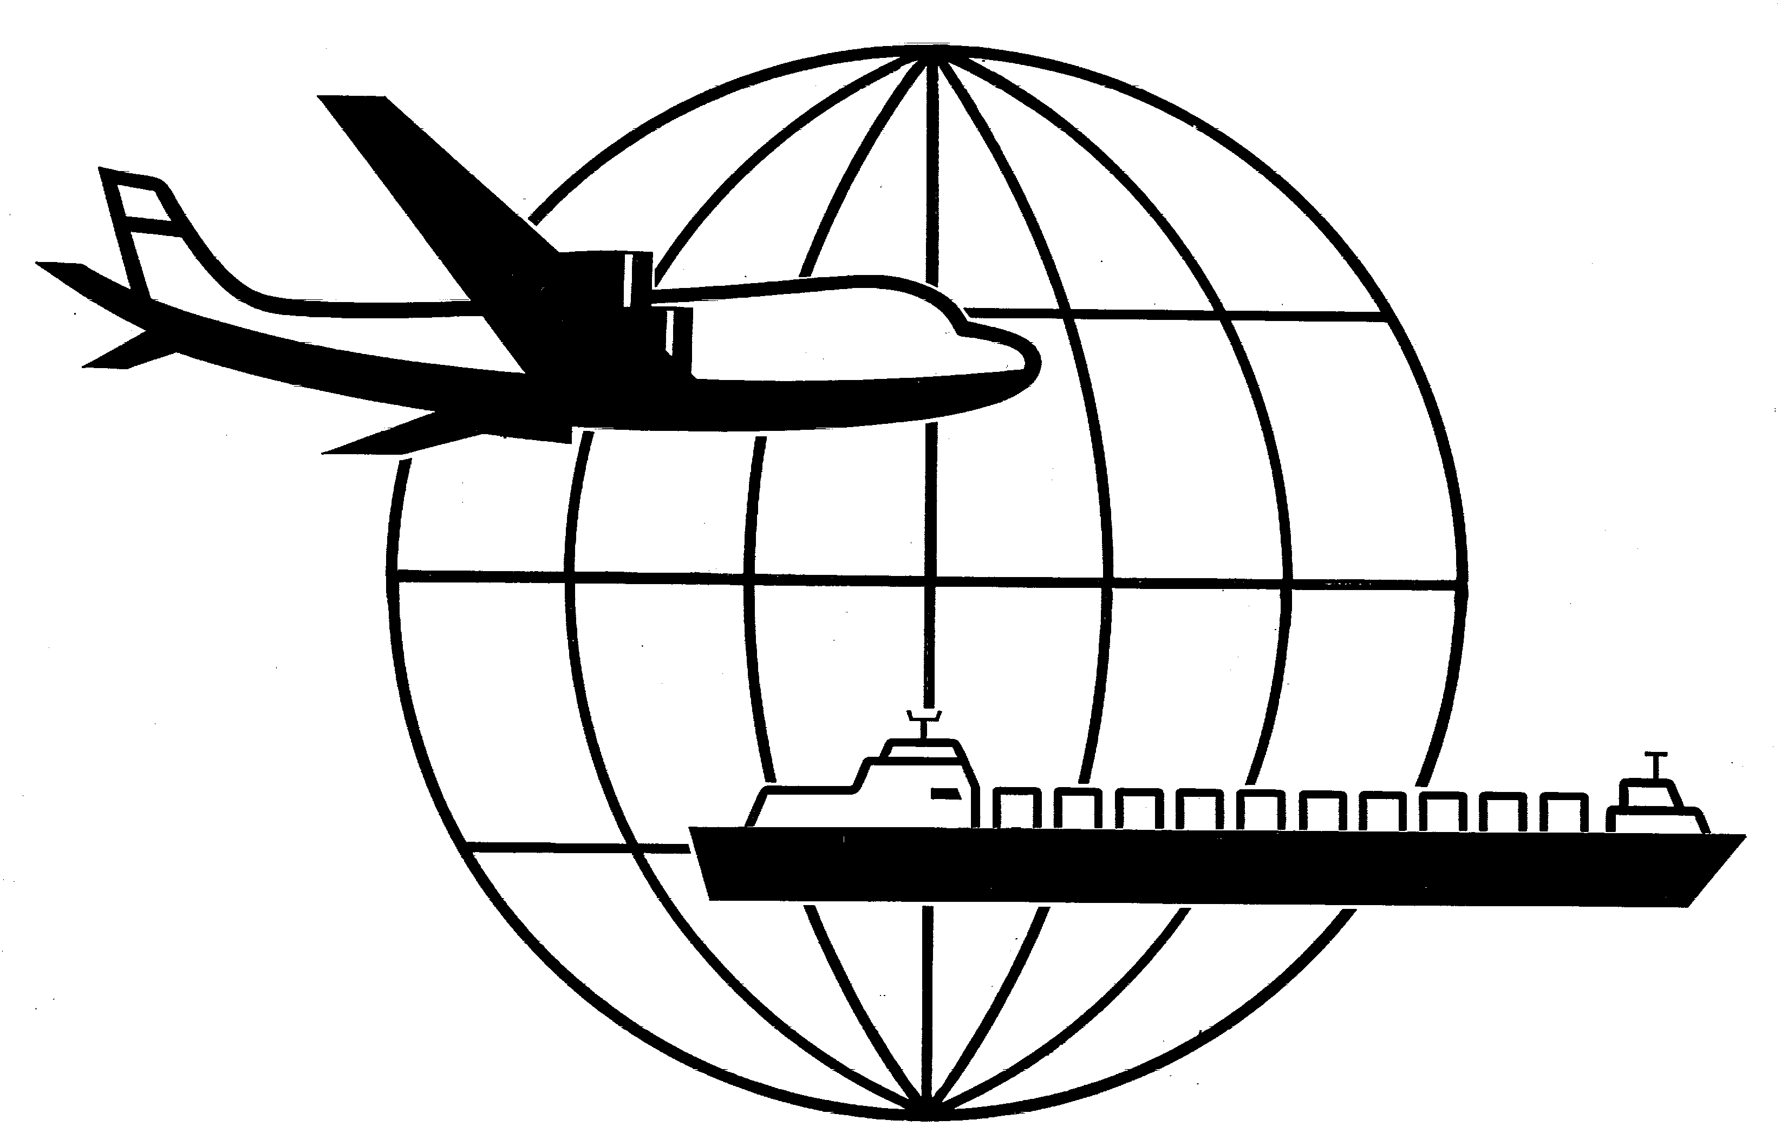
Universal Forwarding Overseas, Ltd.

Newsletter
January, 2002Universal Forwarding Overseas, Ltd.

Euro Official European Union Currency
Circulation of the Euro coin and notes began January 1, 2002. Most EU member states began a phased adoption of the single currency on January 1, 1999. The twelve (12) member states include; Belgium, Germany, Greece, Spain, France, Ireland, Italy, Luxembourg, The Netherlands, Austria, Portugal and Finland. For a wide range of additional information regarding the Euro, its history, use and future please refer to www.europa.eu.int.

US Port and Maritime Security Act
The US Senate approved the Port and Maritime Security Act of 2001. Also referred to as the Hollings-Graham Bill, its focus is to improve the security of America’s transportation system. The House of Representatives must also approve the Bill before it becomes a law. Though the importer must meet specific documentation parameters, the current bill will allow in-bond shipment movement. Under the pending Act, the Exporters are required to submit complete documentation on outbound cargo prior to the vessel’s departure.

USA/Jordan Free Trade Agreement
Duty tariffs of less than 5% will be eliminated this year. Signed October 24, 2000, the free trade agreement will eliminate tariffs on all trade between the USA and Jordan by 2010. Current information outlines the incremental elimination of tariffs as follows; tariff rates of 1-5% by 2002, 6-10% by 2004, 11-20% by 2005, greater than 20% by 2010.

Turkey Business Opportunities
Many experts believe the country of Turkey will provide significant export opportunities for USA manufacturers in upcoming years. A current candidate for entrance into the European Union (EU), Turkey’s strong private sector and massive infrastructure needs place it among the world’s “Big Emerging Markets”, according to the US Commerce Department. For additional information regarding this market, please contact the Turkey desk at the US Dept of Commerce via email: david_de_falco@ita.doc.gov

Consular Legalization - Lebanon
UFO has received information that consular legalization of the commercial invoice is no longer required for the country of Lebanon. UFO encourages you to refer to our website, UFOLTD.COM, for a complete listing of countries that currently require consular legalization.

USA Export to Cuba
On December 16, 2001 the first U.S. steamship carrier transported cargo directly from the U.S. to Cuba in nearly 40 years. The shipment consisted primarily of foodstuffs to aid in the relief effort as a result of Hurricane Michelle. The Trade Sanction Reform and Export Enhancement Act of October 28, 2000 made the transport of goods possible. The Act authorizes the Office of Foreign Assets Control (OFAC) to license the transport of agricultural commodities, medicine, medical devices and other products directly from the United States to the Republic of Cuba.

WISCONSIN
UNIVERSAL FORWARDING OVERSEAS, LTD.
941 North Perkins Street
Appleton, WI 54914
Phone: 920-731-0822
Fax: 920-731-0293

ILLINOIS
UNIVERSAL FORWARDING OVERSEAS, LTD.
1104 Tower Lane
Bensenville, IL 60106
Phone: 630-766-7121
Fax: 630-766-7161

