
Universal Forwarding Overseas, Ltd.

Newsletter
March, 2011Universal Forwarding Overseas, Ltd.
Japan Port Update
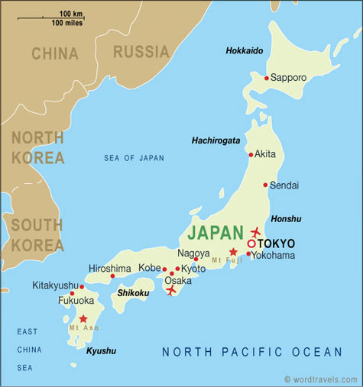

Due to the massive earthquake and resulting tsunami, port operations at select Japanese ports have been suspended or delayed. UFO is able to advise the following information:

- Ports located on Japan's North-East coast are currently not operational including Sendai, Hitachinaka, Onahama, Ofunato & Hachinohe.
- It is reported that several ports in the Hokkaido prefecture, including Tomakomai, are operational.
- Tokyo is partially operational however service is dependant upon terminal/crane status, availability of manpower and/or shortage of electricity supply.
- Information shows that ports in the South and West are operating normally, including Yokohama, Nagoya, Osaka & Kobe.
Service availability to each destination will be on a per shipment basis and the information is subject to change.
Be aware of potential courier delays throughout Japan. If you have any questions, please contact Marc Mugfor, mmugfor@ufoltd.com for additional details.

WISCONSIN
UNIVERSAL FORWARDING OVERSEAS, LTD.
941 North Perkins Street
Appleton, WI 54914
Phone: 920-731-0822
Fax: 920-731-0293

ILLINOIS
UNIVERSAL FORWARDING OVERSEAS, LTD.
1104 Tower Lane
Bensenville, IL 60106
Phone: 630-766-7121
Fax: 630-766-7161

