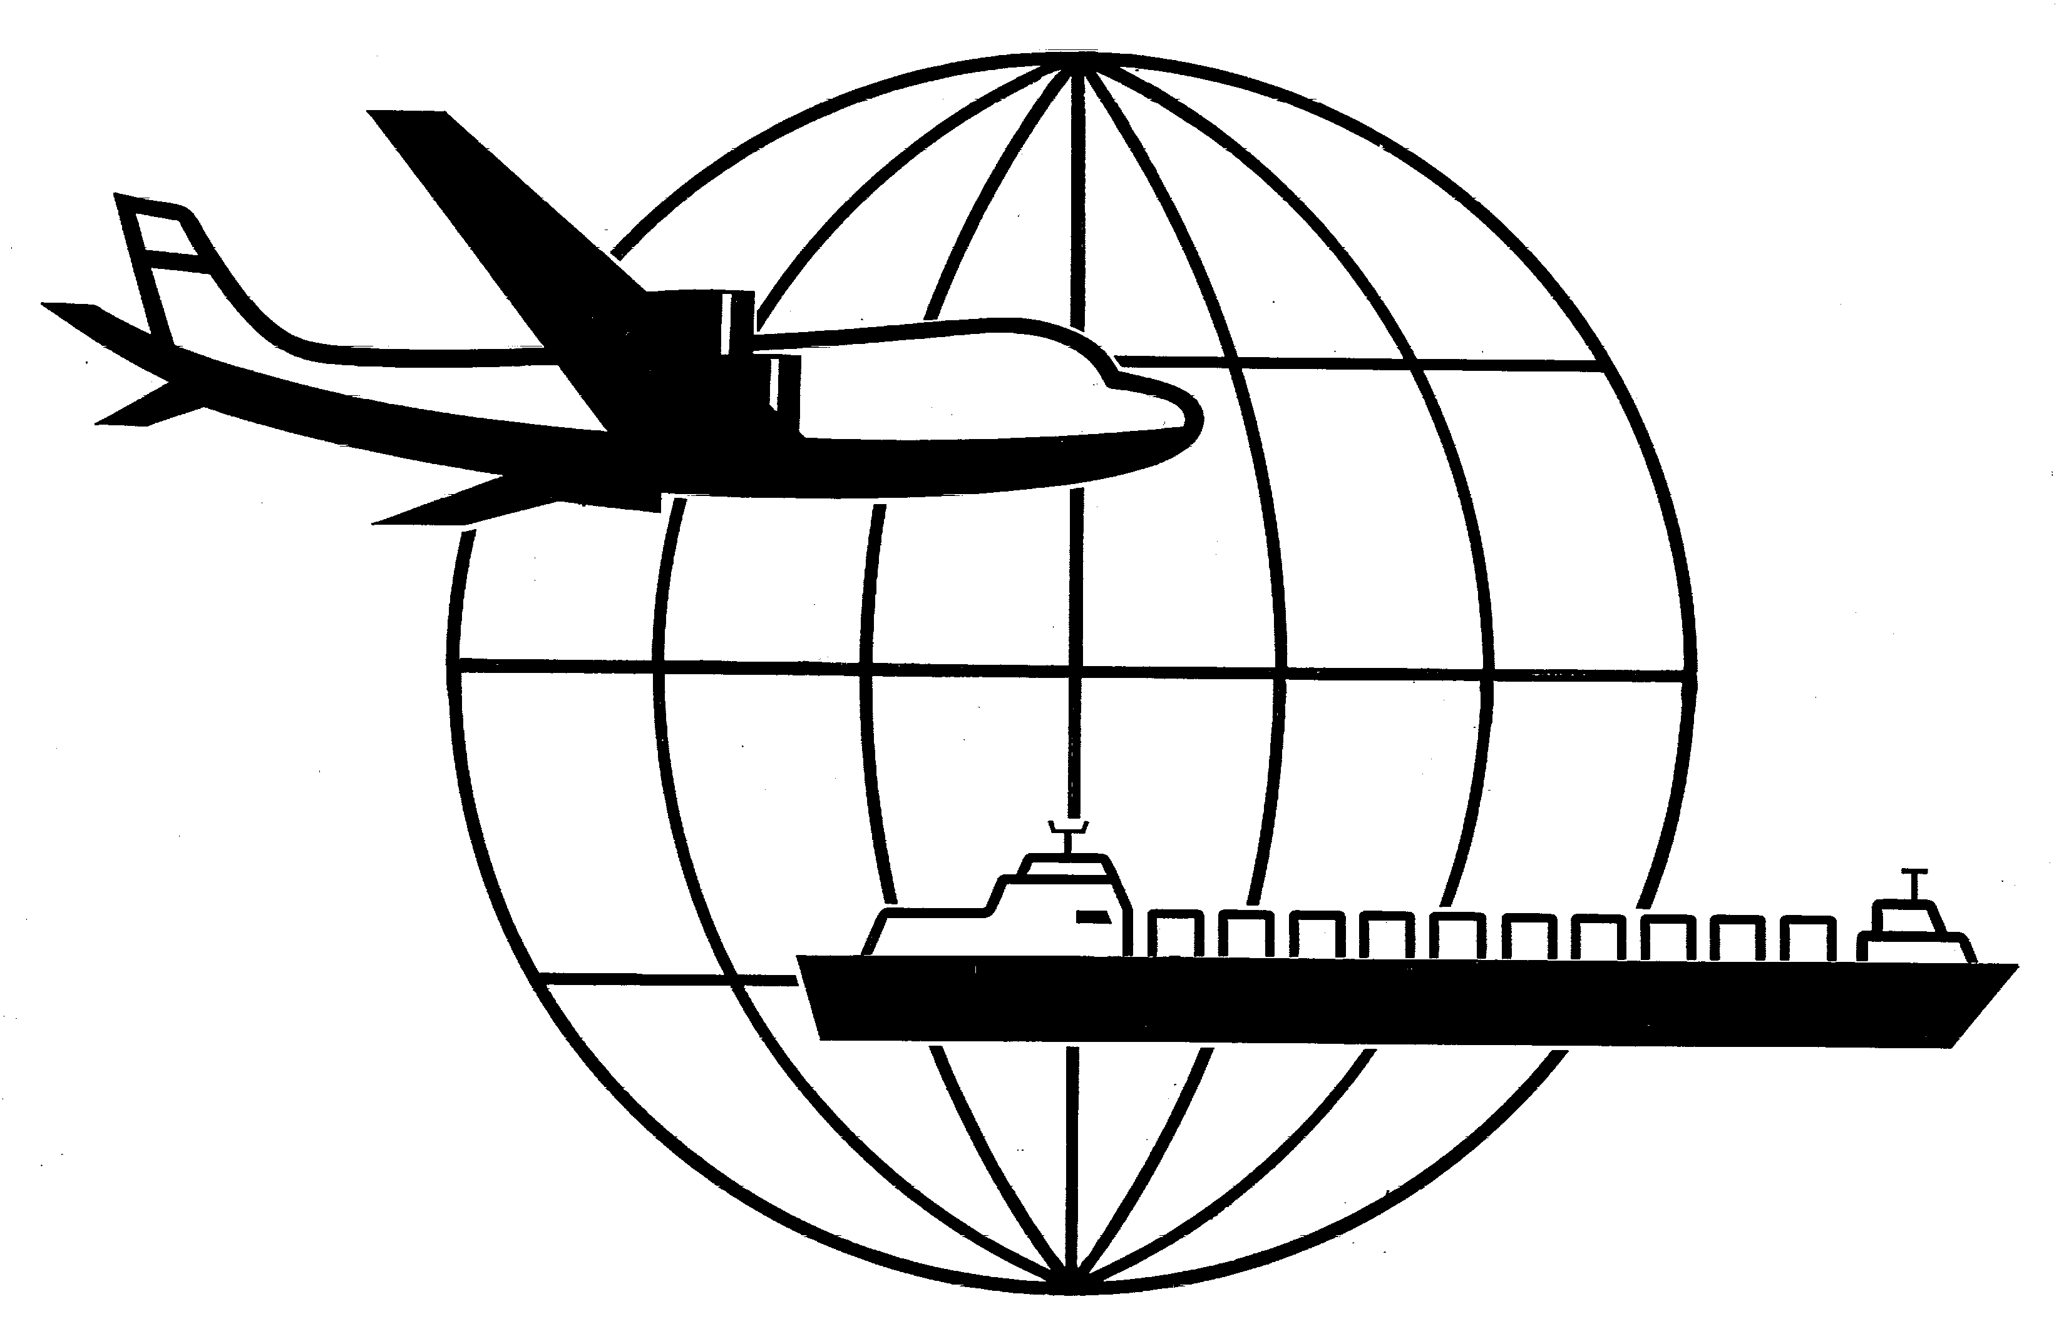
Universal Forwarding Overseas, Ltd.

Bulletin
July, 2003Universal Forwarding Overseas, Ltd.

Canadian Pacific Railroad (CP) – AES Internal Transaction Number (ITN) Requirement

July 14, 2003 the CP will make mandatory a requirement to include the AES ITN on the inland bill of lading for US export shipments utilizing the CP rail to Canadian ports.

The ITN is confirmation the export declaration has been filed with U.S. Customs. This mandatory requirement will affect all exporters filing under Option II. Option II requires the export declaration be filed with Customs prior to departure from the USA. To meet the CP requirement, UFO will file the export transaction on the shipper’s behalf and provide the ITN to the shipper prior to the trucker’s departure from the load facility.

In order to file the export transaction and obtain the ITN, UFO must receive the following information at the time of booking for each transaction; consignee, pieces, weight, value of goods and harmonized code(s). The container and seal number must be advised upon loading. A unique ITN number will be advised to the shipper on a revised UFO booking sheet. The ITN must be on the inland bill of lading provided to the trucker. The shipper will be responsible for all penalties and fees incurred for non-compliance.

An exporter with Option IV filing status is not affected by the new CP requirement. Option IV filing allows for post departure filing of the export declaration.

For additional information regarding this new requirement or assistance in applying for Option IV status, please contact Kathy Parins by telephone or email (920) 731-0822 ext. 31/ kparins@ufoltd.com.

WISCONSIN
UNIVERSAL FORWARDING OVERSEAS, LTD.
941 North Perkins Street
Appleton, WI 54914
Phone: 920-731-0822
Fax: 920-731-0293

ILLINOIS
UNIVERSAL FORWARDING OVERSEAS, LTD.
1104 Tower Lane
Bensenville, IL 60106
Phone: 630-766-7121
Fax: 630-766-7161

