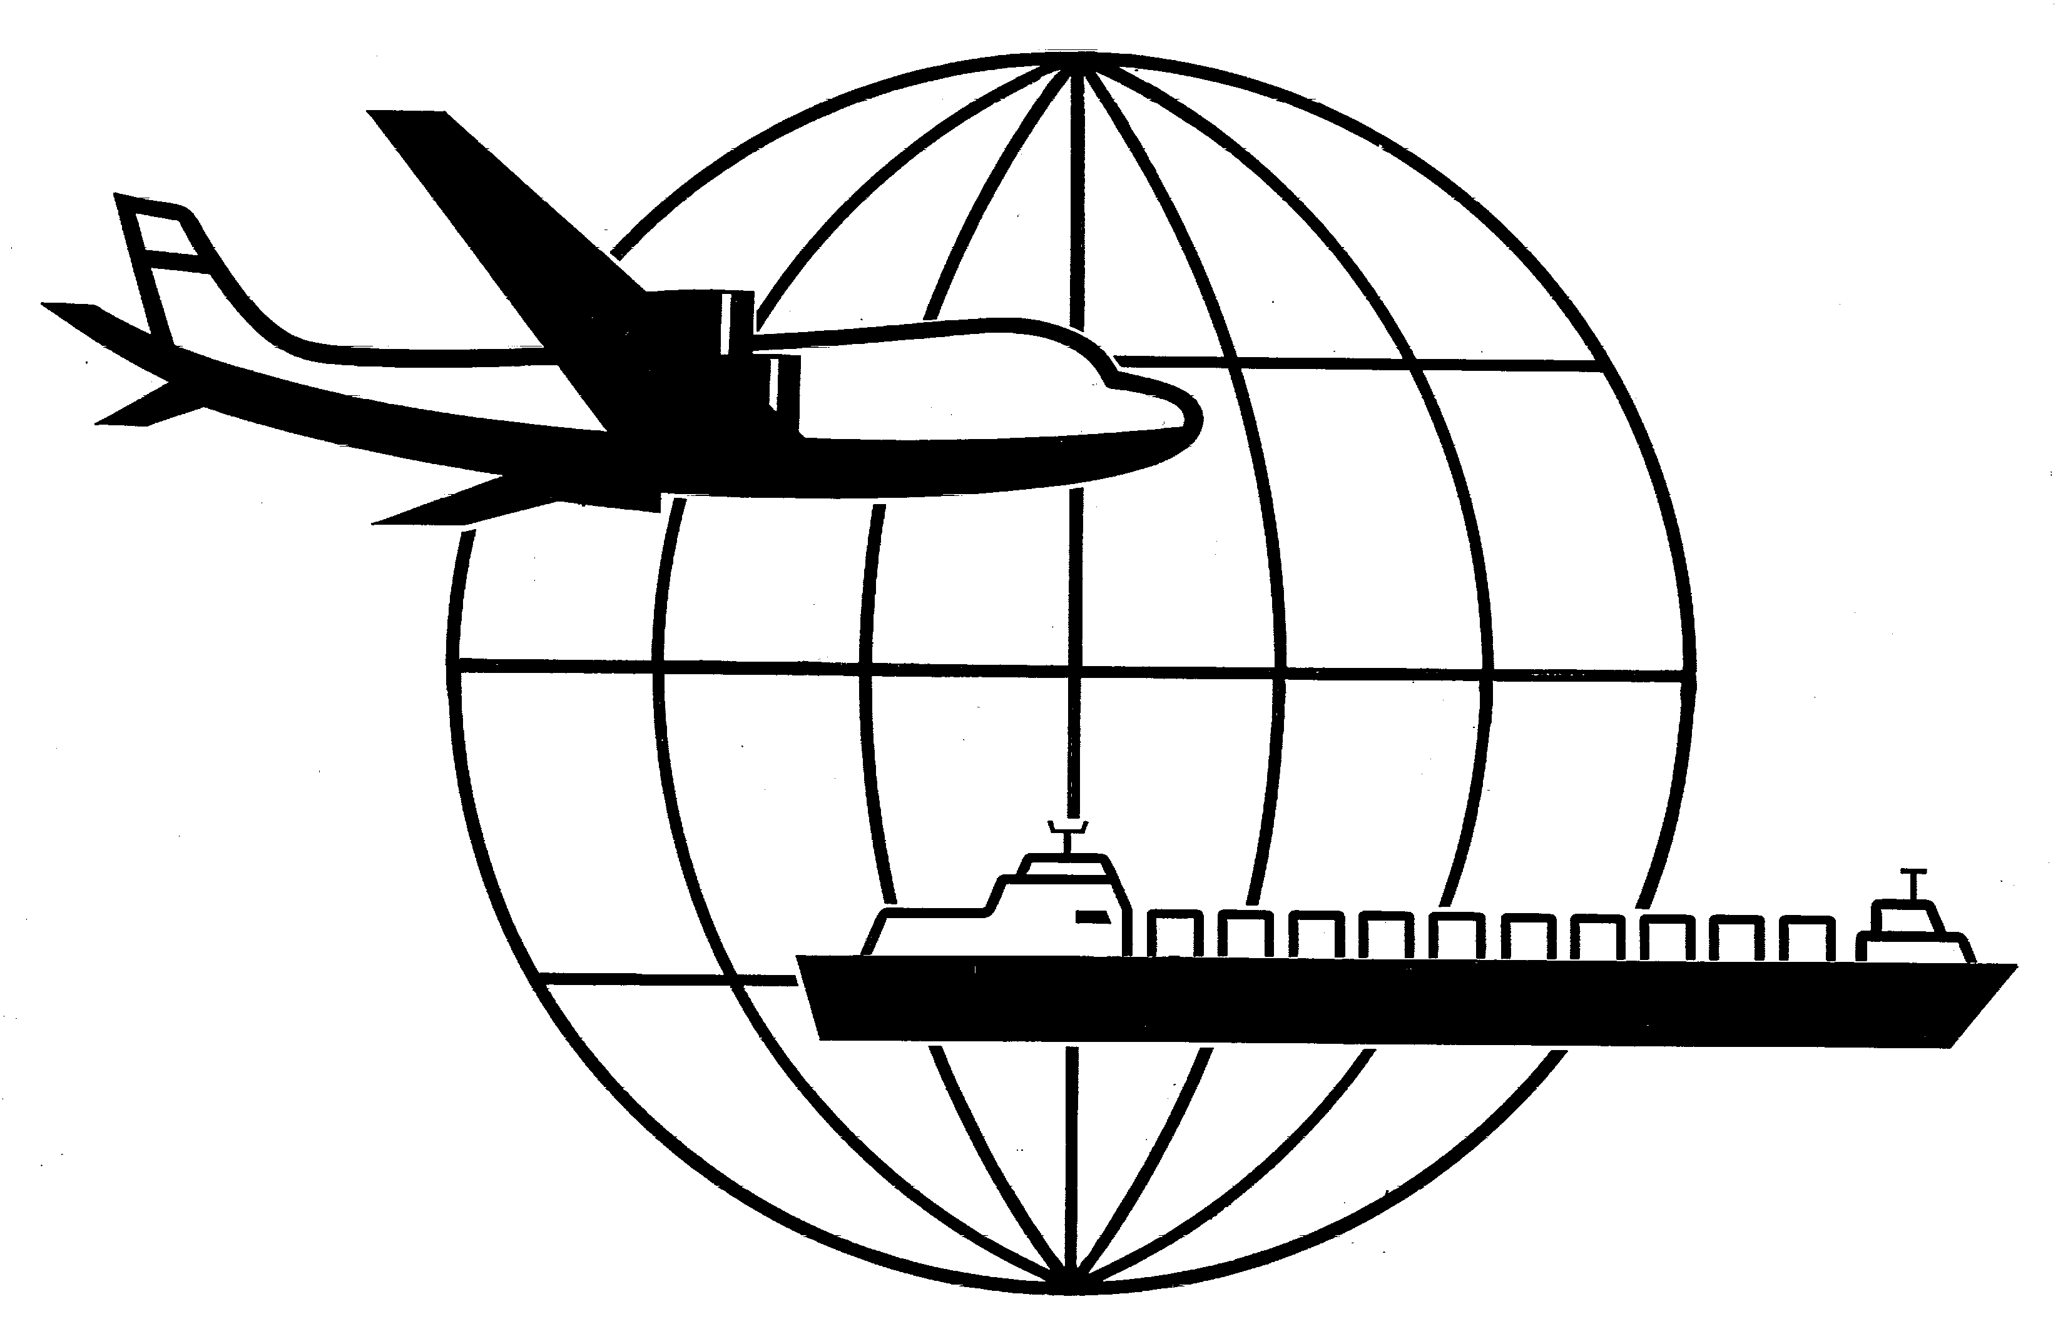
Universal Forwarding Overseas, Ltd.

Newsletter
October 01, 2002Universal Forwarding Overseas, Ltd.

West Coast Contract Negotiations Update

The Pacific Maritime Association (PMA) locked out the International Longshore and Warehouse Union (ILWU) on Sunday, September 29. To date, the lock out is still in place. Terminal operations in Tacoma, Oakland and Los Angeles are shutdown and ILWU workforce is now striking at all West Coast ports.

The PMA position is that they will not open the ports without a contract or contract extension in place. The ILWU has refused to agree to the extensions as it does not allow for strike or work slowdowns.

Greater than 100 vessels are currently detained at West Coast ports. Due to the backlog created by the shutdown, the CSX, NS, BNSF and UP railroads are not dispatching intermodal trains to the West Coast.

The PMA and ILWU continue to work toward a contract extension. The two sides are scheduled to meet today with the Federal Mediation and Conciliation Service for an informational meeting. It is unfortunately not possible to predict any outcome.

Universal Forwarding Overseas, Ltd. (UFO) will continue to carefully monitor the situation and strive to minimize shipment delay.

WISCONSIN
UNIVERSAL FORWARDING OVERSEAS, LTD.
941 North Perkins Street
Appleton, WI 54914
Phone: 920-731-0822
Fax: 920-731-0293

ILLINOIS
UNIVERSAL FORWARDING OVERSEAS, LTD.
1104 Tower Lane
Bensenville, IL 60106
Phone: 630-766-7121
Fax: 630-766-7161

Universal Forwarding Overseas, Ltd.

Newsletter
October 08, 2002Universal Forwarding Overseas, Ltd.

West Coast Work Stoppage Update

Union longshoremen have agreed to go back to work under a 30-day contract extension proposed by the Bush administration in a negotiation to avoid invoking the Taft-Hartley Act. It is unclear if shipping lines have accepted the 30-day contract extension.

The Taft-Hartley Act governs collective bargaining in the United States. It includes a process for mediating strikes or lockouts that threaten national emergencies. The President used his statutory authority under the Taft-Hartley Act to convene a Board of Inquiry to examine the work stoppage at the West Coasts ports.

The West Coast ports have been closed since the second shift on Sunday, September 29, when the Pacific Maritime Association (PMA) shut down the ports in response to a reported work slow-down by members of the International Longshore and Warehouse Union (ILWU).

Containers previously scheduled to sail on/after September 29 will be rescheduled by steamship lines for the timeliest arrival at destination. Under the extenuating circumstances, carriers are working to minimize any additional costs to shippers. Some steamship lines have declared Force Majeure, as they are unable to perform services due to the work stoppage.

WISCONSIN
UNIVERSAL FORWARDING OVERSEAS, LTD.
941 North Perkins Street
Appleton, WI 54914
Phone: 920-731-0822
Fax: 920-731-0293

ILLINOIS
UNIVERSAL FORWARDING OVERSEAS, LTD.
1104 Tower Lane
Bensenville, IL 60106
Phone: 630-766-7121
Fax: 630-766-7161

