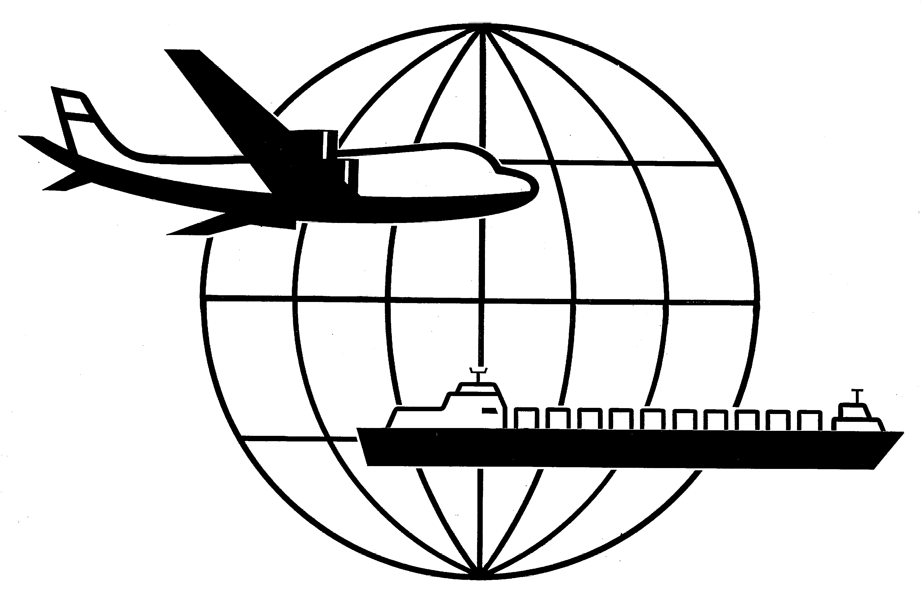
,
Universal Forwarding Overseas, Ltd.

Newsletter
December, 2000Universal Forwarding Overseas, Ltd.

CHASSIS SURCHARGE
Steamship lines currently providing a chassis for inland transportation at no cost, have announced a chassis surcharge of $40-$60 per use, effective 01 January, 2001. In doing so, they hope to help cover the costs of capital depreciation, insurance, positioning and maintenance, which have so far been included in the cost of ocean freight.

PRESHIPMENT INSPECTION
Many countries require pre-shipment inspection in order to verify that imports meet quality, price and customs classification requirements. For shippers exporting to a country where pre-shipment inspection is required, following the proper procedure can alleviate needless delays and costs.
- Importer contracts inspection company for upcoming shipment and to arrange for payment.
- The inspection company contacts the exporter to arrange a date, time and location for inspection.
- Once the inspection is complete, a “Clean Report of Findings” is issued by the inspector and used by importer in customs
clearance into the destination country.
UFO recommends confirming with the importer if pre-shipment inspection is required for a specific order. If you are unsure of which countries require pre-shipment inspection, please request a list from your UFO sales representative.

BAF INCREASE
Due to high fuel costs, several carriers have announced a BAF increase effective 01 December to all of South America. The increase varies depending on steamship line and destination.

AUSTRALIA DIRECT RATE INCREASE
Shippers should be aware of a pending rate increase for direct shipments to Australia. The exact amount of the rate increase depends on the commodity of the shipment, but ranges from $120 - $210 per TEU. Please note that this increase does not affect shipments to Australia which are transshipped via Asia.

SHIPPER’S LIABILITY FOR HAZARDOUS FREIGHT
According to a recent court ruling, shippers are responsible for notifying carriers of hazardous shipments and any special handling requirements even though they may not have a contractual agreement with the carrier. This means that even if the consignee is responsible for transportation and freight costs, it is still the shipper’s responsibility to notify the carrier of special handling requirements.

AUTOMATED FILING OF SHIPPERS EXPORT DECLARATIONS (SED)
As reported in earlier newsletters, as of 01 November, 2000, US customs is no longer accepting SED’s via fax. UFO has been successfully filing SED’s electronically for several months. If your company has not yet been approved for Option 4, we encourage you to contact your UFO sales representative for specific information.

WISCONSIN
UNIVERSAL FORWARDING OVERSEAS, LTD.
941 North Perkins Street
Appleton, WI 54914
Phone: 920-731-0822
Fax: 920-731-0293

ILLINOIS
UNIVERSAL FORWARDING OVERSEAS, LTD.
1104 Tower Lane
Bensenville, IL 60106
Phone: 630-766-7121
Fax: 630-766-7161

