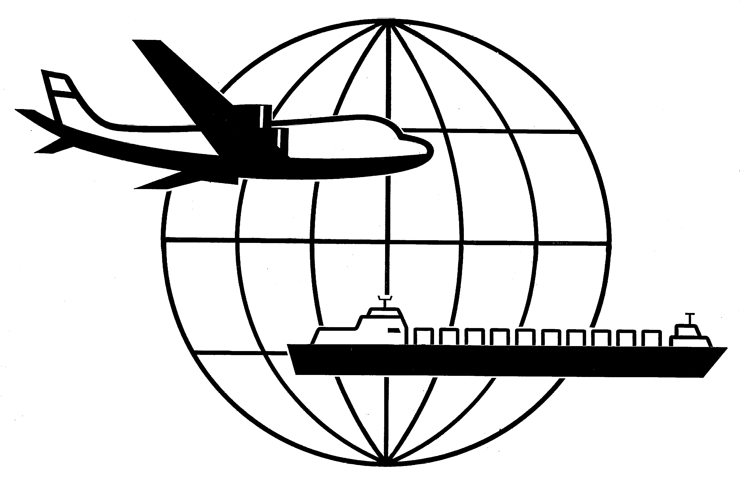
Universal Forwarding Overseas, Ltd.

Newsletter
April, 2002

Argentina Pre-Shipment Inspection
Pre-shipment inspection is no longer required for shipments moving into Argentina. Previously pre-inspection to Argentina was based on the commodity being imported to this country.

Trade Promotion Authority

Chile – US Free Trade Agreements closer to approval
According to President Bush, a free-trade agreement with Chile may be finalized in the year 2002. The talks of the agreement have been stalled due to a US Senate debate over whether the Executive Branch should be granted the authority to independently negotiate trade agreements. This policy, known as Trade Promotion Authority (TPA) by the current Administration, would provide President Bush the power to negotiate trade agreements. Under TPA, Congress would have no ability to amend a trade agreement, only limited authority to confirm or reject the agreement.

2002 Schedule B

The final version of the 2002 Schedule B, Export Commodity Classification Schedule and the Harmonized Tariff Schedule (HTS) is available on the Bureau of Census’ Foreign Trade Division website at www.census.gov/foreign-trade. UFO encourages you to access this web site via www.ufoltd.com

Export Alert!
The U.S. Department of Commerce, recently launched Export Alert!, a free Internet-based service that automatically notifies participating businesses when foreign governments propose regulations that may impact U.S. exports. Export Alert! gathers, organizes and disseminates notifications of proposed regulatory changes issued by any of the 142 member nations of the World Trade Organization (WTO). For additional information, please refer to http://ts.nist.gov/ts/htdocs/210/217/export-alert.htm or phone 301-975-4040.

Alameda Corridor Opens April 12, 2002
This corridor, constructed to facilitate the movement of containers and reduce congestion, is a 20-mile rail cargo expressway between the ports and the transcontinental rail yards near Los Angeles. Several steamship carriers are currently assessing a charge to shippers that is reflected on the ocean bill of lading. The charge will be $15/20’ container and $30/40’ and 40’ HC container. Slightly higher fees will be assessed for 45’, 48’ and 53’ containers.

WISCONSIN
UNIVERSAL FORWARDING OVERSEAS, LTD.
941 North Perkins Street
Appleton, WI 54914
Phone: 920-731-0822
Fax: 920-731-0293

ILLINOIS
UNIVERSAL FORWARDING OVERSEAS, LTD.
1104 Tower Lane
Bensenville, IL 60106
Phone: 630-766-7121
Fax: 630-766-7161

