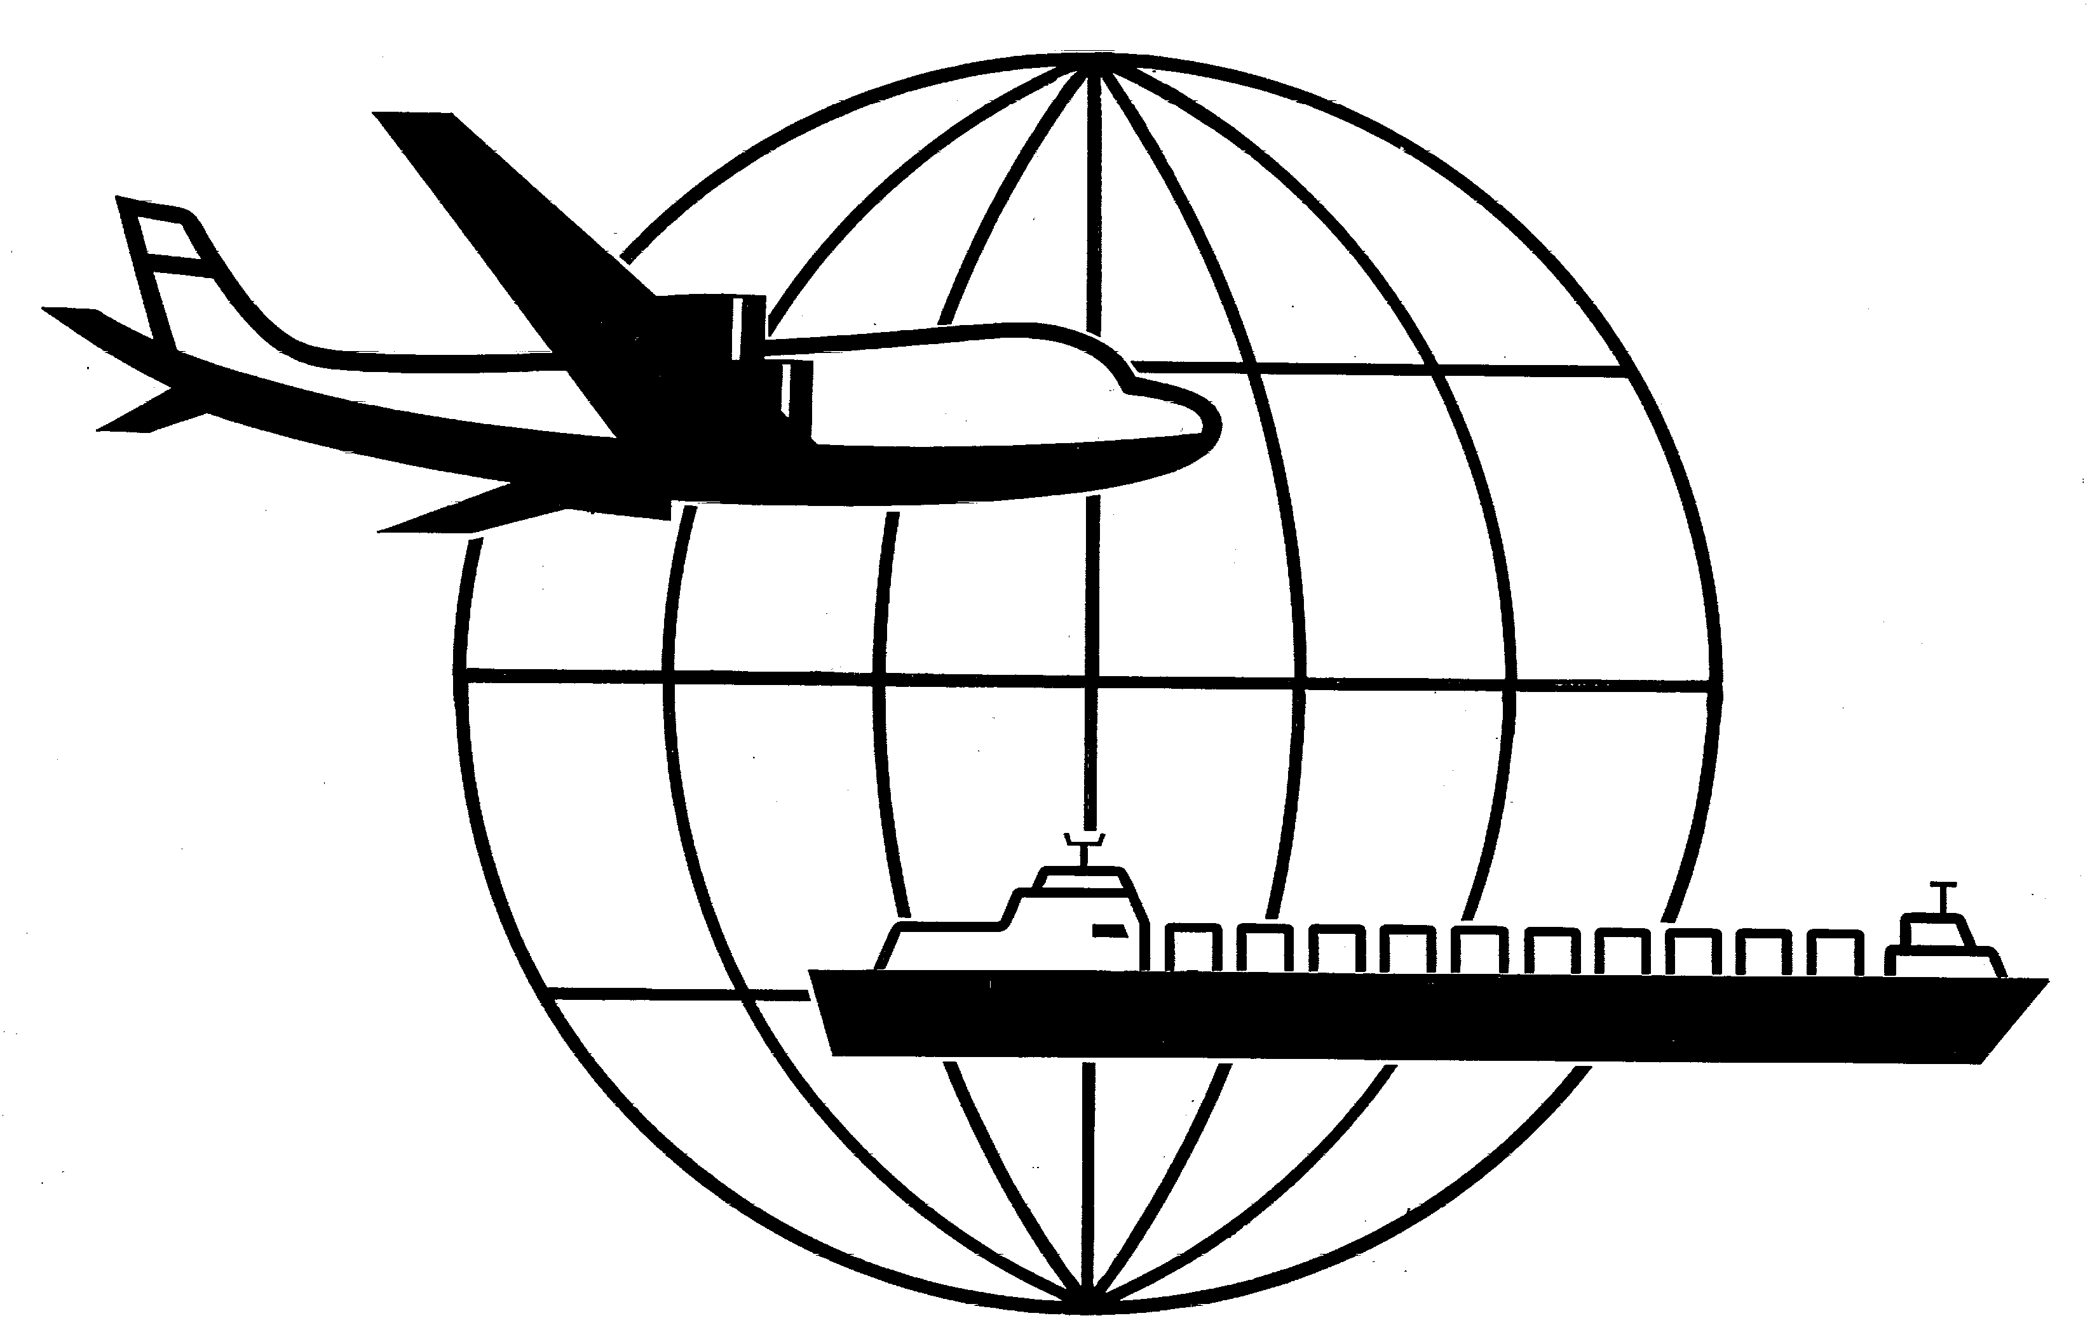
Universal Forwarding Overseas, Ltd.

Newsletter
August, 2002Universal Forwarding Overseas, Ltd.

Customs-Trade Partnership Against Terrorism (C-TPAT)
C-TPAT is a joint government-business initiative to build cooperative relationships that strengthen overall supply chain and border security. By participating in this first worldwide supply chain initiative, companies will ensure a more secure supply chain for their employees, suppliers and customers. C-TPAT is currently open to all importers and carriers (air, rail and sea). For additional information, please contact Industry Partnership Programs at (202) 927-0520 or refer to www.customs.gov/enforcem/tpat_fact.htm.

International Long Shore and Warehouse Union (ILWU) Contract Negotiations
ILWU and the Pacific Maritime Association (PMA) plan to resume negotiations on Tuesday, August 13. The ILWU continues to work under an extension of the old contract, which expired July 1, 2002. A key issue in the talks has been the PMA's insistence on work-rule changes that would make it easier for management to introduce laborsaving technology.

BXA has a New Name
The Commerce Department recently announced that the Bureau of Export Administration (BXA) will be renamed the Bureau of Industry and Security (BIS). It is said that BIS more effectively describes the board scope of the agency’s responsibilities. The Bureau of Industry and Security serves the public in various means in which industry and national security intersect, including export licensing, enforcement, defense trade advocacy and critical infrastructure protection. For more information regarding BIS, please refer to www.bxa.doc.gov.

Trade Promotion Authority Approved by Senate
The US Senate recently approved a bill giving President Bush broader authority to negotiate trade agreements. Under the new legislation, Congress would have no authority to change any trade agreement negotiated by the President before voting for or against the trade agreement. The House has already approved this bill.

WISCONSIN
UNIVERSAL FORWARDING OVERSEAS, LTD.
941 North Perkins Street
Appleton, WI 54914
Phone: 920-731-0822
Fax: 920-731-0293

ILLINOIS
UNIVERSAL FORWARDING OVERSEAS, LTD.
1104 Tower Lane
Bensenville, IL 60106
Phone: 630-766-7121
Fax: 630-766-7161

